GOOGLE REVIEW

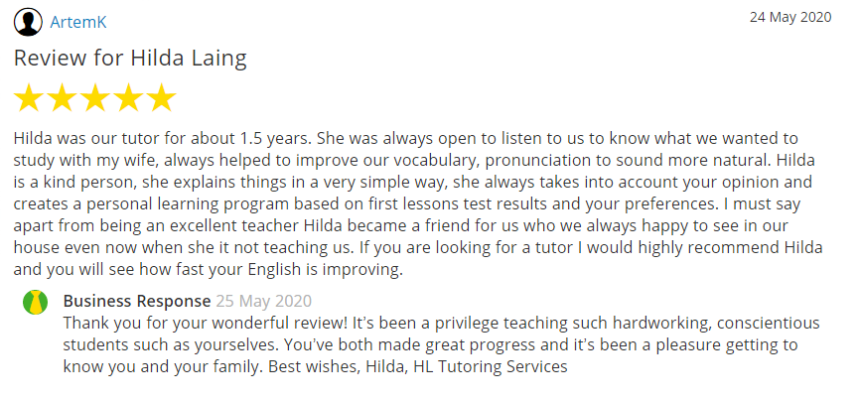
YELL REVIEW

GOOGLE REVIEW

FACEBOOK REVIEW
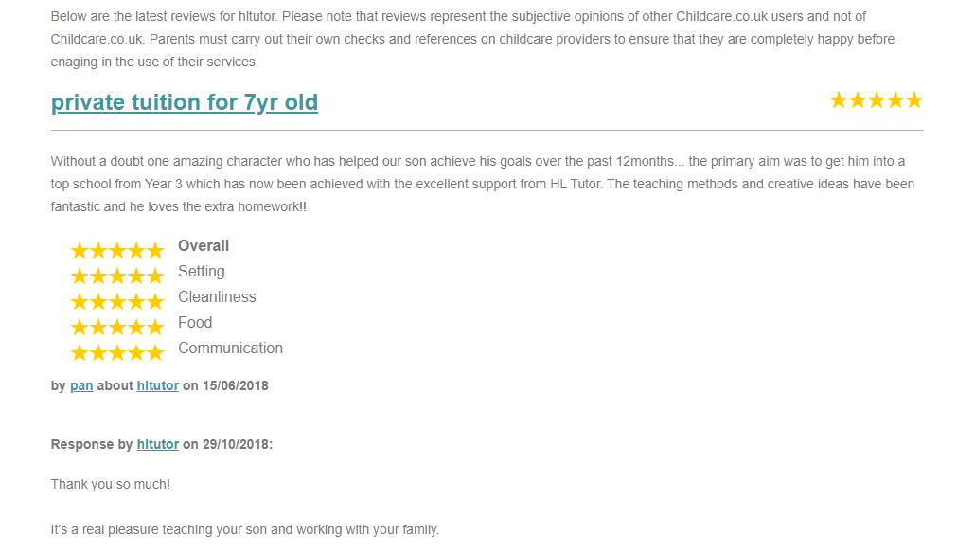
CHILDCARE.CO.UK REVIEW
GOOGLE REVIEW

